TF-Luna Parameter Variation Report

Design Of Experiment

* **Objective:**

The purpose of this experiment is to quantify how TF-Luna’s reported signal strength varies as we systematically change four key factors:

* + Distance between sensor and target
  + Frame rate (i.e. measurement interval)
  + Ambient environment (lighting condition)
  + Object colour
* **Parameter Definitions:**

| **Parameter** | **Levels / Set-Points** |
| --- | --- |
| **Distance** | 20 cm, 50 cm, 100 cm, 200 cm, 400 cm, 600 cm, 800 cm |
| **Frame Rate (Hz)** | 10 Hz (100 ms interval), 50 Hz (20 ms), 100 Hz (10 ms), 150 Hz (≈7 ms), 200 Hz (5 ms), 250 Hz (4 ms) |
| **Environment** | 1. Direct Sunlight2. Ambient Room Light3. Low light / Night (dark room) |
| **Object Colour** | 1. Normal (mid-tone)2. White3. Black |

* **Observations & Interpretations:**

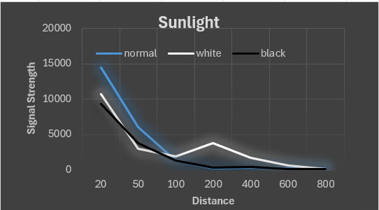

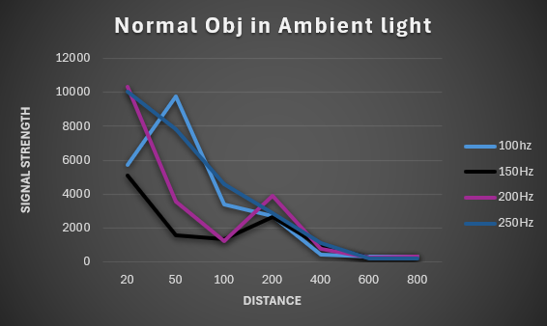

* **OBSERVATIONS:**

1. ***Effect of Light Conditions (Sunlight, Ambient, Night)*** -

* Signal strength decreases with increasing distance in all lighting conditions.
* Night yields highest signal strength across distances.
* Sunlight results in the lowest signal strength, especially beyond 100mm.
* Ambient light performance lies between night and sunlight.

1. ***Effect of Object Colour –***

* Black objects reflect the least signal in sunlight and ambient conditions.
* At night, black objects show the strongest reflection at short distances.
* White objects perform better in ambient light, especially at shorter distances.
* Normal (neutral-colored) objects generally show stable mid-range performance.

1. ***Frequency Variation (Under Ambient Light) –***

* Higher frequencies (e.g. 250 Hz) show slightly better signal strength up to 200mm.
* Lower frequency (150 Hz) exhibits weaker and inconsistent performance.
* **INFERENCES**

1. ***Light Interference:***
   * **Sunlight introduces noise**, degrading the sensor's signal detection efficiency.
   * **Night operation** is ideal due to minimal light interference.
2. ***Colour Reflectivity:***
   * **Black absorbs** more light → weaker signals.
   * **White reflects** more light → stronger signals, especially in ambient light.
3. ***Distance Sensitivity:***
   * Signal reliability **drops sharply beyond 200mm**, regardless of conditions or object type.
4. ***Best Operating Conditions:***
   * For **maximum signal strength**, use sensor **at night or in controlled ambient light** with **lighter-coloured objects** and **higher operating frequencies**.